|  |  |  |  |  |  |
| --- | --- | --- | --- | --- | --- |
| Unit 2  Mathematics Methods  Investigation # 4  Differentiation  Take Home   |  |  | | --- | --- | | **Name** |  |   **Important Information:**  *Although the take-home component is not worth any marks, it is essential in preparation for the in-class component. Knowledge and skills gained will be extended in the in-class validation component. This in-class validation will be completed under test conditions on the day in which this take-home component is due. The take-home component may be used when completing the in-class component.* | | | |
| **Take home component weighting:** | *0% of the year* | **In-class component weighting:** | *5 % of the year.* |

***You may use your out of class section as notes for this test. CAS calculator permitted.***

**Optimisation**

**Extended investigation Part 1:** **Preparation activity**

**Problem 1: Which solar panel has the greatest area?**

The area of a glass solar panel needs to be at a maximum to “collect” the greatest amount of sunlight possible. The shape of the flat solar panel is allowed to vary but the metal strip around the edge of the panel (i.e., around the perimeter) is to be kept at a constant value of 8 m to minimise the cost of making the object. For the shapes provided, determine the area of the various panels and hence identify the shape with the maximum area.

A. Glass panel is square

The metal strip is 8 m. Determine the length of each side and hence the area of the square panel.

B. Glass panel is triangular in shape with all sides equal

The metal strip is 8 m. Determine the length of each side and hence calculate the area of the triangular panel using the formula 

C. Hexagonal panel

The metal strip is 8 m and the panel is in the shape of a regular hexagon. Draw a labelled diagram to represent the panel identifying the length of the sides and the sizes of the equal angles. Use a dissection method and the formula  to show that the area of the panel is  where *a* is the length of each side.

D. Circular panel

The metal strip is 8 m. Determine the radius of the circular panel and hence the area of the panel.

***Examining your results***

Rank the four shapes provided in order of increasing area.

What feature of these shapes seems to be influencing this order of magnitude?

Suggest a possible range of values for the area of a regular pentagon with a perimeter of 8 m. Justify your choice of values. Calculate the area of the pentagon and relate your answer to the range of values that you predicted.

**Problem 2: Which raised garden bed can contain the greatest volume of soil?**

Raised garden beds come in a variety of shapes and sizes. Four three-dimensional shapes have been suggested for investigation. Assuming each of these shapes can be filled with soil, what is the maximum amount of soil each of the shapes can contain? The dimensions referenced refer to the inner measurements and the thickness of the garden bed can be assumed to be negligible.

For each of the shapes provided

* There is a given restriction on the relationship between some dimensions.
* Identify the formula for the volume of the shape.
* Use Calculus techniques to determine the dimensions that maximise the volume.
* Use the following directions to identify the maximum volume.

A. Garden bed is the shape of a rectangular prism

(a) The formula for the volume of a rectangular prism is  .

(b) Given  metres and the height (*h*) is half of the width, state the formula for Volume in terms of *h* only.

(c) Determine  , the derivative of the expression for Volume.

(d) Let = 0 and solve for *h.*

[Note: Volume has a maximum value when the derivative is zero]

(e) Determine the other dimensions of the garden bed. Note that  metres and the height (*h*) is half of the width.

(f) Substitute these values for *h, l* and *w* back into the formula for Volume as determined in part (b) and hence determine the maximum volume of soil that can be contained in this garden bed in the shape of a rectangular prism.

B. Garden bed has the shape pictured below

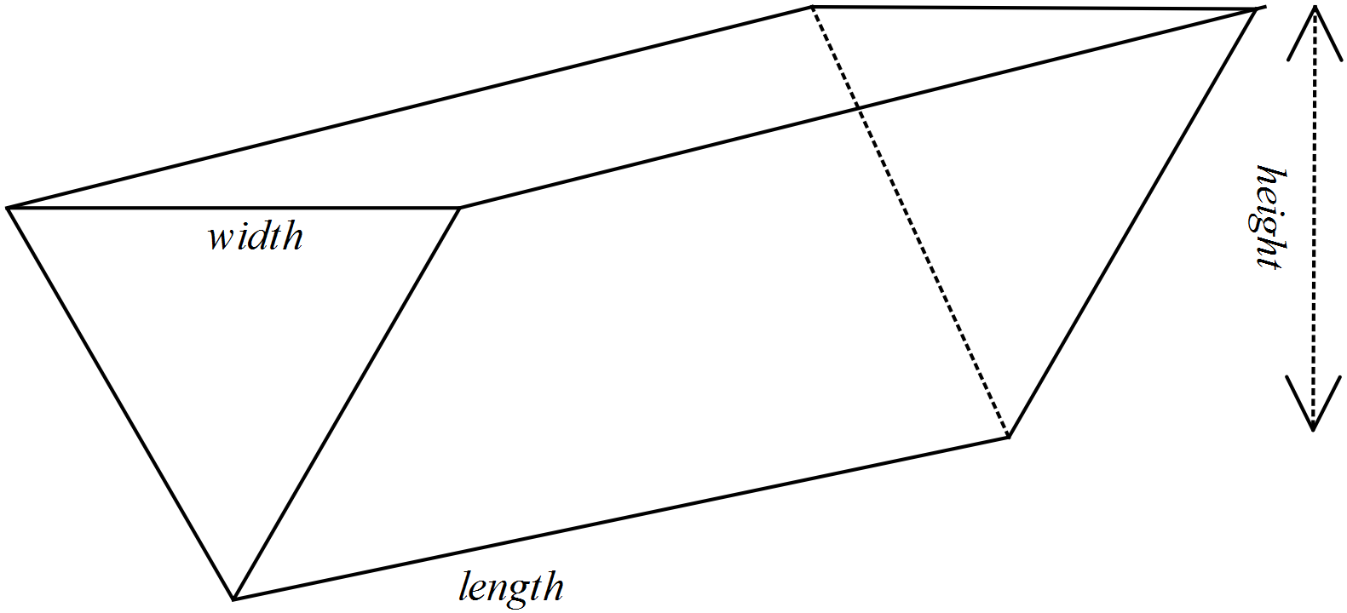

(a) The formula for the volume of this triangular prism is  .

(b) Given the length plus width is 5 metres () and the height (*h*) is a quarter of the width, state the formula for Volume in terms of *w* only.

(c) Determine  , the derivative of the expression for Volume.

(d) Let = 0 and solve for *w.*

[Note: Volume has a maximum value when the derivative is zero]

(e) Determine the other dimensions of the garden bed. Note that  metres and the height (*h*) is a quarter of the width

(f) Substitute these values for *h, l* and *w* back into the formula for Volume as determined in part (b) and hence determine the maximum volume of soil that can be contained in this garden bed in the shape of a triangular prism.

C. Cylindrical garden bed

(a) The relationship between the height and the radius of a cylindrical garden bed is  metres. Show that the rule for calculating the volume of the garden bed is .

(b) Use Calculus techniques to show that the volume is a maximum when the radius is  metres.

(c) Determine the height of the garden bed when the volume is maximised.

(d) Determine the maximum volume of this cylindrical garden bed.

D. Garden bed in the shape of a hexagonal prism

The surface of the garden bed is in the shape of a regular hexagon. The volume of the prism is given by  .

(a) Use the formula for area from Problem 1 plus the restriction that  metres, where *a* is the length of each side of the hexagon, to generate a formula for volume in terms of *a* only.

(b) Use Calculus techniques to show that a maximum volume of 12.028 m3 occurs when  metres.

(c) Calculate the height of the garden bed when the volume is maximised.

***Examining your results***

Enter your results in a table as follows:

|  |  |  |  |
| --- | --- | --- | --- |
| Shape | Restriction | Dimensions for maximum volume | Maximum volume |
| Rectangular prism |  |  |  |
| Triangular prism |  |  |  |
| Cylinder |  |  |  |
| Hexagonal prism |  |  |  |

Comment on your results, considering the following questions.

1. Can you conclude that a particular shape will give a maximum volume? Explain your decision.
2. Are any of the measures i.e., volume or dimensions the same for two or more shapes?
3. Would you expect the length to equal the height in the rectangular prism given this situation? Explain your decision.

4. What other methods, i.e., other than Calculus techniques could be used to determine the maximum volume of these 3-dimensional shapes? What are the advantages of using calculus techniques?